Health and Wellness
Theses two words are commonly used as interchangeably. Different people have different perspective and define them accordingly. However, Health is synonymous as state of being free from any kind of ailment or injury while wellness is synonymous as performance of healthy habits for achieving healthy physical and mental outcomes. One can’t have health without wellness.

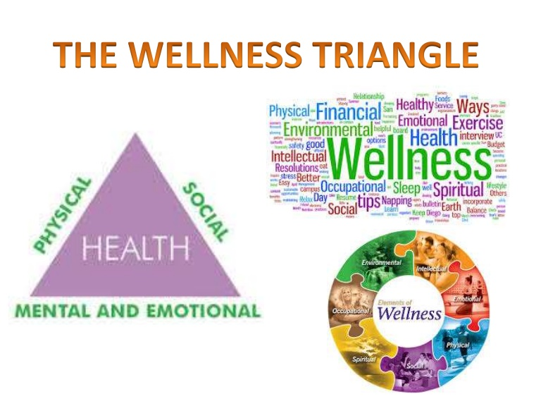
According to WHO health and wellness is defined as;
Health is a state of complete physical, mental and social well-being and not merely the absence of disease or infirmity.
It means when you have sound health you can perform well in your daily life either it is school, college, playground, university, workplace or household.
Physical fitness is not only consideration for healthy human being. There are different parameters for determining health and wellness. Some are listed here:
- Physical
- Social
- Mental
- Emotional
- Spiritual
- Environmental
- Occupational
- Nutrition

So, one should maintain all these parameters in balance in order to cherish all pleasures and luxuries of life.
“Life is great blessing, make it more valuable by loving, caring and helping others.”

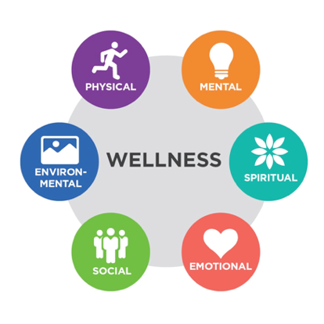

How to maintain health and wellness
Here are the important footsteps to be followed to achieve and maintain sound health:
- Exercise regularly: Human body is beautifully structured for handling different things, it can be anything either mentally, physically or spiritually. But for achieving consistency and persistency in all these forms, exercise is must, for every person irrespective of age and gender. Here I have listed one example:

Neurotransmitters are known as chemical messengers being produced at neuronal junction (two neurons forming synapse with each other) to trigger action potential same as button used to turn on the light and removing darkness from room. More you exercise the more you will get balanced neurotransmitters in your body and the more active, healthy and well you will feel.

Problems related to inadequate exercise:
Heart problems, problems related to breathing, Obesity, anxiety-stress induced problems, problems with digestion.

- Have balanced diet: Nutrition is very important for maintaining healthy life style. Balanced diet means a diet comprising of adequate quantities and proportion of protein, fat and carbohydrate that body needs along with minerals and vitamins. Healthy diet is going to protect you from malnutrition as well as non-communicable diseases.
The healthier you eat, the healthier you will be - that will lead to healthier society and economy.

Problems related to nutrition:
Malnutrition: it depicts low body weight due to specific nutrient deficiency e.g. protein deficiency in mother lead to poor development of fetus eventually results in premature birth or birth with body deformities i.e., kwashiorkor and marasmus diseases.

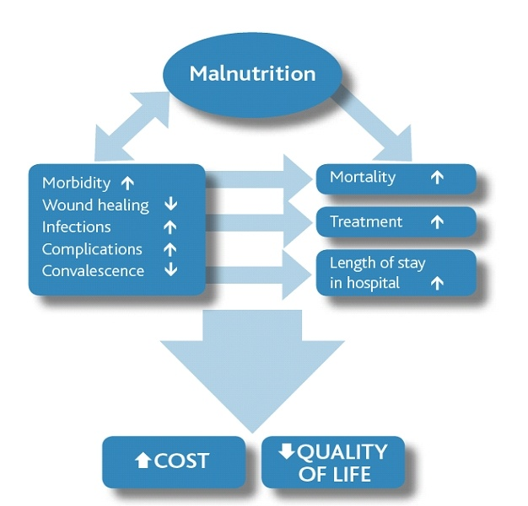
Anemia: which is iron deficiency commonly found in girls and women from age 10-45 years due to menstruation. It is one of the leading causes of poor performance and early dropout from school in young girls.
Vitamin D deficiency: this deficiency is the leading cause of Rickets in children and Osteomalcia in adults. It is due to poor intake of calcium and vitamin D. Here point to be noted that calcium will get absorbed in the body only in presence of vitamin D i.e., 1,25-chlolecalciferol.

- Be environment friendly: environment plays a crucial role in healthy life style. Spare few minutes from your daily routine and spend time with nature. As, Nature is a great healer. Spending time with tress, inhaling beautiful essence of captivating views will clear the thoughts and will decrease the risk of acquiring cancerous diseases.



- Be a social person: spending quality time with friends, family and other community members establish good personal relationships, and keep long term relationships intact as well. Which will make someone feel healthier and happier, with sense of responsibility and credibility. This will also give rise to equality and equity in society with minimum crime rate.
“Helping, loving, sharing and caring are ways of living.”


- Be intellectual: intellectual is a way of thinking critically, finding ways to be creative and being open to new ideas. Be intellectual will open a number of ways upon you leading to creativity and prosperity. As you all know very well, that prosperity is directly proportional to healthy lifestyle.

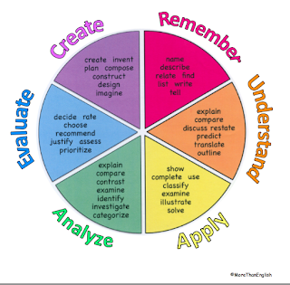
Indication of intellectual wellness:
- Making yourself aware of what you are and what you are blessed with.
- Managing time and developing good study-based skills.
- Discovering yourself as critical thinker.
- Being open to new ideas, people, and belief.

Link: https://www.unh.edu/health/wellness

- Emotional wellness: it counts for your emotions, ability and thought that make you able to deal with different circumstances and challenges of life.

Indications of emotional wellness:
- Feeling free to tell somebody about your feeling and emotions concerning others.
- Being proud of yourself.
- Feeling free to express apology for whatever you are guilty.
- Having guts to say no for what you don’t like.
- Can able to relax yourself in unwanted condition.

Indicates:
Anxiety and depression
Indicates:
Social dysfunction and depression
Symptoms:
Not able to face problems
Feeling unhappy and depressed
Losing confidence
Not able to enjoy day to day activities
Thinking of oneself as worthless and not useful

\
Symptoms:
Decrease in concentration
Losing sleep
Feeling not useful
Feeling incapable of making decisions
Feeling constantly under strain
Feeling that one cannot overcome the difficulties

https://www.google.com/url?sa=i&url=https%3A%2F%2Fwww.researchgate.net%2Ffigure%2FFactors-Reported-in-GHQ-That-Affect-Emotional-Well-being_tbl4_333146523&psig=AOvVaw1OAnfOLkl0PJH6YUYQJziC&ust=1616238819114000&source=images&cd=vfe&ved=0CAkQjhxqFwoTCIDvh_ecvO8CFQAAAAAdAAAAABAU
- Spiritual wellness: it can be defined as cutting your connection with external world and connecting yourself with your inner voice. It will make you think of who are you? What is the purpose of your life? Why you are being sent in this world?

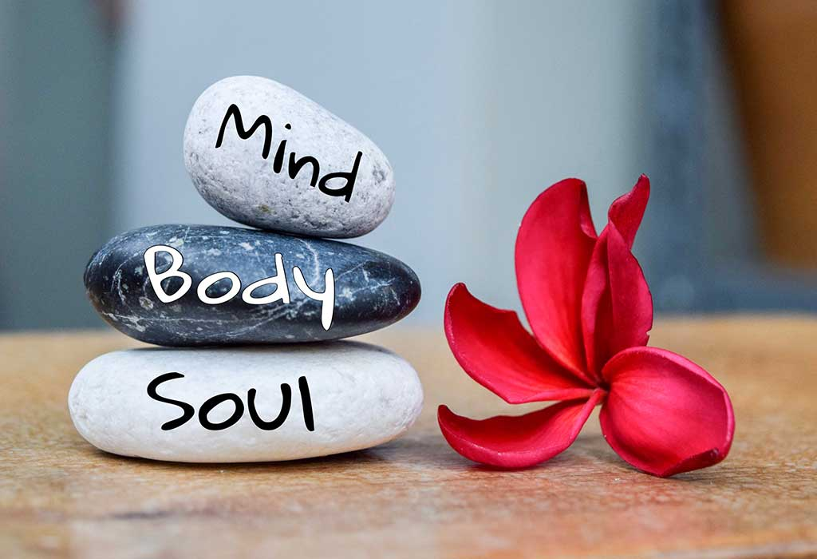 Ways to improve spiritual health and wellness:
- Think positive: when you start thinking positively you will find your mood happy and healthier. While repelling all negative forces around you. When you think positive you will think better and useful.
- Try yoga: yoga helps in reducing stress, blood pressure, anxiety, restlessness, fatigue, insomnia, and depression while boosting immune response. It can do so by reducing physical and emotional strain on your mind and body. There are different techniques available to perform it.
- Approach for deeper meaning in your life: look for the happening in your life and analyze whether do you have command on your fate or not? You will have beautiful and healthy life after getting this. Because you can know yourself and can create flexibility in your life then.
- Make your thoughts clear: by following this you can focus on one thing with your full potential, concern and attention. You can make your thoughts expressive and know how to deal with your brain at spot.
Link: http://illinoisstate.edu/

- Mental health and wellness: The most important and typically less weightage considered topic around the world is mental health. We have to understand its importance in order to make healthy, well and peaceful lifestyle which eventually lead to prosperous and economically stable society.

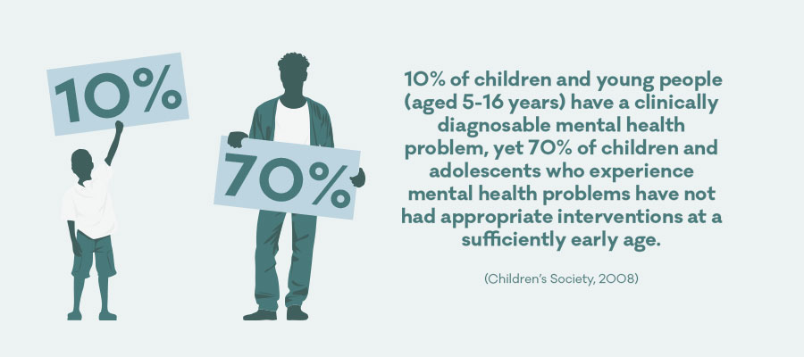
https://www.google.com/url?sa=i&url=https%3A%2F%2Fwww.mentalhealth.org.uk%2Fstatistics%2Fmental-health-statistics-children-and-young-people&psig=AOvVaw3gkPBjauIrFqppZmuF9gNk&ust=1616248252425000&source=images&cd=vfe&ved=0CAkQjhxqFwoTCIj-8ZTAvO8CFQAAAAAdAAAAABAW
Mental health is all about social, psychological and emotional well-being of a person. It helps person to think, behave, react and to fight with life challenges. There are different contributing factors to mental health:
- Experiences gained through life e.g., trauma, injury, abuse.
- Family history related to mental health.
- Genetic factor and brain chemistry.
Positive mental health provides people with:
- Power to face with stressful faces of life.
- Generate more productive and creative work.
- In realization of person’s competitive potential.
- Giving society a positive and meaningful contribution.
Link: https://www.mentalhealth.gov/ . In case of any mental issue, contact psychologist to get your health fit and soulful.

